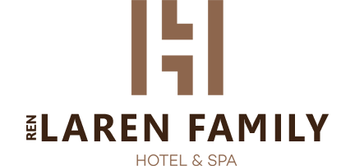

LAREN FAMILY HOTEL & SPA
2020 SUMMER SEASON FACTSHEET

CATEGORY : Boutique Class

CONCEPT : Bed and breakfast_Half board_All inclusive

ADDRESS : Caglayan street N.2069, No: 11/1Muratpasha, Antalya

TELEPHONE : + 90 (242) 3511515

FAKS : + 90 (242) 3235455

WEB ADDRESS : www.larenbusinesshotel.com

E-MAİL ADDRESS : info@larenbusinesshotel.com

SEASON : 12 Months

RECEPTION : 24 Hours

ROOMS AND BEDS :59 /129

C/IN - C/OUT : 14.00 / 12.00

C/IN - C/OUT : 14.00 / 12.00

OPENİNG YEAR : 2019

LOCATION : Antalya City center 8 KM
Antalya Airport 6 KM
Expo Center 8 KM

TYPES OF PAYMENT : Visa, Eurocard, Mastercard, Cash

SPOKEN LANGUAGES : Turkish, English, Deutch, Russian,Persian, Arabic

DOMESTIC ANIMALS : Pets are not allowed

WİFİ : Free of charge in the rooms and hotel areas
HOUSEKEEPING :Every 2 days
TOWEL CHANGE : Every 2 days
SHEET CHANGE : Every 2 days
MINI BAR : Water (changed daily)
BABYSITER : Rented for a daily fee.
BABY STROLLER :Rented for a daily fee.
WHEELCHAIR :Available
FREE HOTEL SERVICES : Fitness Center, Okey,Chess, Backgammon
PAİD HOTEL SERVICES : Faks, Telefon,Photocopy Drycleaner, Laundry, Safebox, Room service
FOR HONEY MOONERS : Roomdecoration,Fruitbasket, Champagne or Wine,Nuts
FOR SPECİAL DAYS :Special celebration packages are available for a fee ( cake, flowers and others )

ROOMS

Comfort Room with balcony :
48 Room / 24 square m
French or Twin bed, WC &Shower, Hairdryer, Satellite brodcasting, LED TV, Telephone, Safebox, Mini bar, Split airconditioner, Floor laminate, Balcony, Make up desk, Wireless internet,Tea and coffee set up.
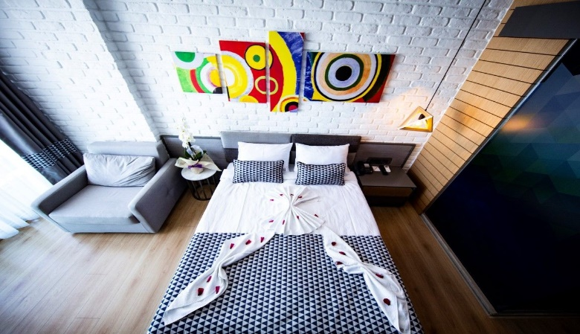
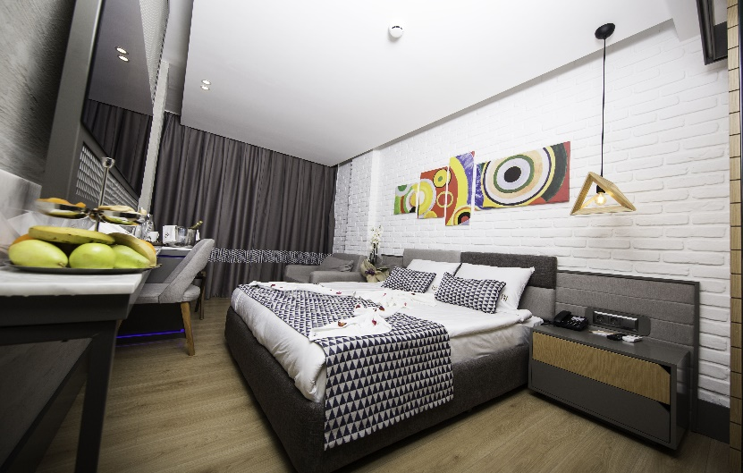

Deluxe comfort Room without balcony :

6Oda / 30 square m
Double or Single bed, WC &Shower, Hair dryer, Satellite brodcasting, LED TV, Telephone, Safebox, Mini bar, Split airconditioner, Floor laminate, Balcony, Make up desk, Wireless internet,Tea and coffee set up.

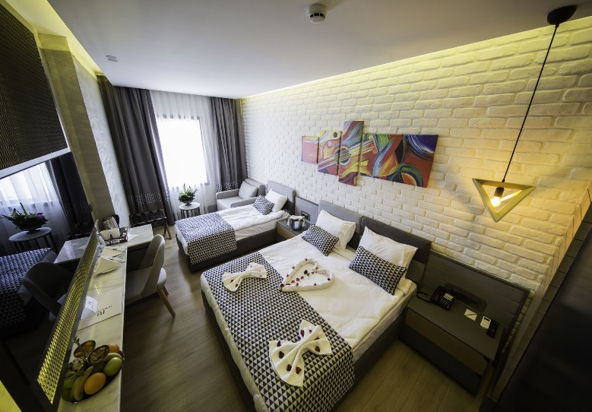

Suit Room:
5Oda / 47 square m
Double or Single bed, armchair, jakuzzi, WC &Shower, Hair dryer, Satellite brodcasting, LED TV, Telephone, Safebox, Mini bar, Split airconditioner, Floor laminate, Balcony, Make up desk, Wireless internet,Tea and coffee set up.

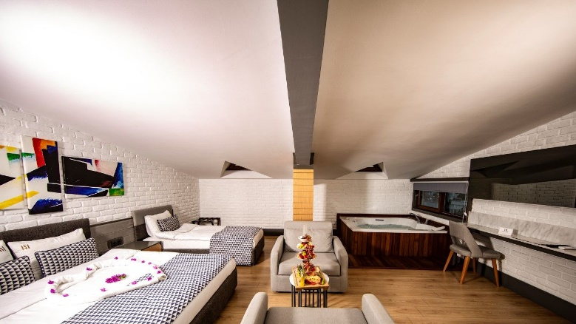
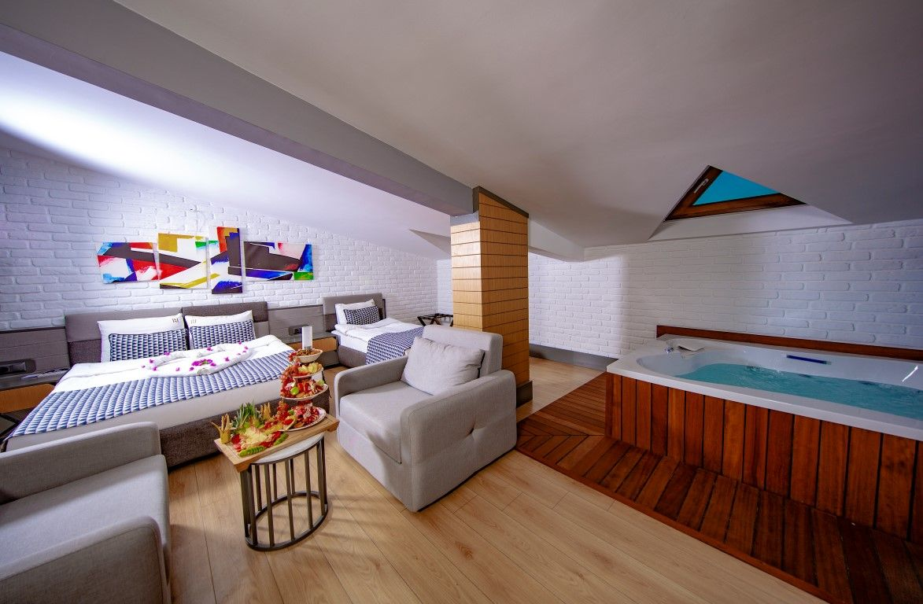

FOOD & BEVERAGE SERVICE UNITS

ALL INCLUSIVE :

PLACE | CONTENT | SERVİCE HOURS | NOTE
RESTARAUNT | OPEN BUFFET | 07:00 – 10:00 BREAKFAST  10:00 – 10:30 LATE BREAKFAST  12:30 – 14:30 LUNCH  19:00 – 21:00 SUPPER  23:30--24:00 LATE SUPPER  23.30-24.00 GECE YEMEĞİ | OPENING –CLOSING HOURS CAN CHANGE . DEPENDS ON FILLING.  FREE OF CHARGE
LOBBY BAR |  | 24 SAAT | 10:00 – 23:00  FREE OF CHARGE
POOL BAR |  | 10:00 – 23:00 | FREE OF CHARGE
DISCO BAR |  | 23:00 – 02:00 | OUT OF FREE CHARGE
ODA SERVİSİ |  | 24 SAAT | OUT OF FREE CHARGE
VİTAMİN BAR |  | 24 SAAT | OUT OF FREE CHARGE
ÇAY SAATİ |  | 16:00 – 16:45 | FREE OF CHARGE
SNACK |  | 15:30 – 16:30 | FREE OF CHARGE

AI CONCEPT BEVERAGE DETAİLS:
Free drinks : Unlimited alcoholic and non-alcoholic beverages
Chargeable drinks : Freshly squeezed fruit juices, Champagne, Cans and bottle drinks, foreign drinks

PLACE | CONTENT | SERVICE HOURS | NOTE
RESTARAUNT | OPEN BUFFET | 07:00 – 10:00 BREAKFAST  10:00 – 10:30 LATE BREAKFAST  19:00 – 21:00 SUPPER | OPENING –CLOSING HOURS CAN CHANGE . DEPENDS ON FILLING.  FREE OF CHARGE
LOBBY BAR |  | 24 HOURS | OUT OF FREE CHARGE
POOL BAR |  | 10:00 – 23:00 | OUT OF FREE CHARGE
DİSCO BAR |  | 23:00 – 02:00 | OUT OF FREE CHARGE
ROOM SERVICE |  | 24 HOURS | OUT OF FREE CHARGE
VITAMIN BAR |  | 24 HOURS | OUT OF FREE CHARGE
TEA HOURS |  | 16:00 – 16:45 | OUT OF FRE CHARGE
SNACK |  | 15:30 – 16:30 | OUT FREE CHARGE

HB CONCEPT DETAILS :

Half board details :
Only soft drinks are free for breakfast and dinner. Lunch is charged in our restaurant.

PLACE | CONTENT | SERVİCE HOURS | NOTE
RESTARAUNT | OPEN BUFFET | 07:00 – 10:00 BREAKFAST  10:00 – 10:30 LATE BREAKFAST | OPENING –CLOSING HOURS CAN CHANGE . DEPENDS ON FILLING.  FREE OF CHARGE
LOBBY BAR |  | 24 HOURS | OUT OF FREE CHARGE
POOL BAR |  | 10:00 – 23:00 | OUT OF FREE CHARGE
DISCO BAR |  | 23:00 – 02:00 | OUT OF FREE CHARGE
ROOM SERVİCE |  | 24 HOURS | OUT OF FREE CHARGE
VITAMİN BAR |  | 24 HOURS | OUT OF FREE CHARGE
TEA HOURS |  | 16:00 – 16:45 | OUT OF FREE CHARGE
SNACK |  | 15:30 – 16:30 | OUT OF FREE CHARGE
B&B

.
Half board details :
Only soft drinks are free for breakfast and dinner. Lunch is charged in our restaurant.

BEACH AND POOL

 | Piece | Depth
Oudoor Pool | 1 | 140cm
Jakuzzi (Outdoor pool and SPA Center) | 2

Beach service hours : Free of charge

Departure: 9 : 05 – 10 : 05 – 12 : 05 – 14 : 05
Return : 10:30 – 12:30 – 14:30 – 15:30 – 16:30

SPA

Free SPA Service : Sauna, Turkish Hamam, Steam Room
Chargeable SPA Service : Massage , Lifting

*Hotel Management reserves the right to change or abolish the above-mentioned services and services under certain conditions ( inconvenience of weather conditions, occupancy rates, force majeure,etc)

